**Introduction**

The ability to analyze supermarket sales data effectively is essential for gaining valuable insights into customer behavior, product performance, and overall business operations. This project focuses on exploring a comprehensive dataset of supermarket sales to answer critical business questions, as outlined in the accompanying project document. By addressing these questions, we aim to uncover actionable trends and patterns to support strategic decision-making.

The scope of this project encompasses several key areas of analysis, including customer demographics, product and pricing performance, sales trends, profitability, and multivariate analysis. Some of the questions we aim to answer include identifying the branch with the highest sales, understanding customer purchasing behavior based on membership status, evaluating the performance of different product lines, and determining the impact of payment methods on revenue.

**SUPERMARKET SALES ANALYSIS**

**CREATED BY**

**MD TANVIR ANAYETULLA**

**Data Collection**

For this analysis we need a supermarket sales dataset. So kaggle.com is the best way to get dataset. There are hundreds of datasets uploaded here and I can create my own datasets. To collect a proper dataset I first took help from chatgpt to find out which dataset from kaggle.com is good for me. Accounting related and sales related dataset in chatgpt between kaggle.com website chatgpt gives me idea about supermarket sales report. Then I went to the kaggle.com website and searched by typing supermarket sales report and I got this dataset which link is <https://www.kaggle.com/datasets/aungpyaeap/supermarket-sales>. The primary dataset, containing detailed supermarket sales records, was obtained in Excel format.

|  |  |
| --- | --- |
| **Row Labels** | **Sum of gross income** |
| **Electronic accessories** | **2587.5015** |
| A | 872.2435 |
| B | 811.9735 |
| C | 903.2845 |
| **Fashion accessories** | **2585.995** |
| A | 777.7385 |
| B | 781.5865 |
| C | 1026.67 |
| **Food and beverages** | **2673.564** |
| A | 817.2905 |
| B | 724.5185 |
| C | 1131.755 |
| **Health and beauty** | **2342.559** |
| A | 599.893 |
| B | 951.46 |
| C | 791.206 |
| **Home and lifestyle** | **2564.853** |
| A | 1067.4855 |
| B | 835.6745 |
| C | 661.693 |
| **Sports and travel** | **2624.8965** |
| A | 922.5095 |
| B | 951.819 |
| C | 750.568 |
| **Grand Total** | **15379.369** |

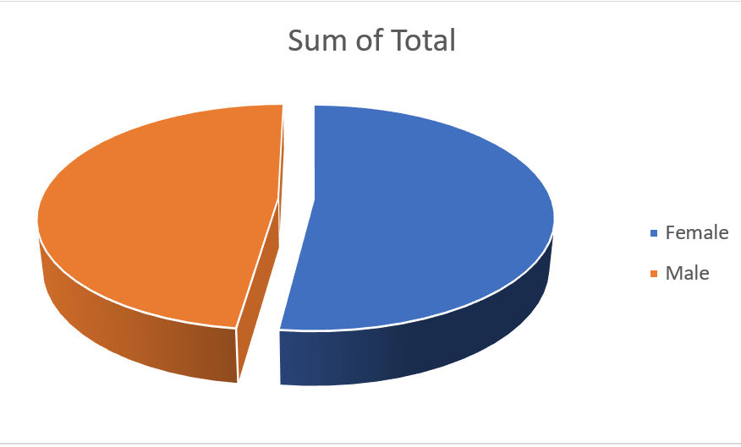 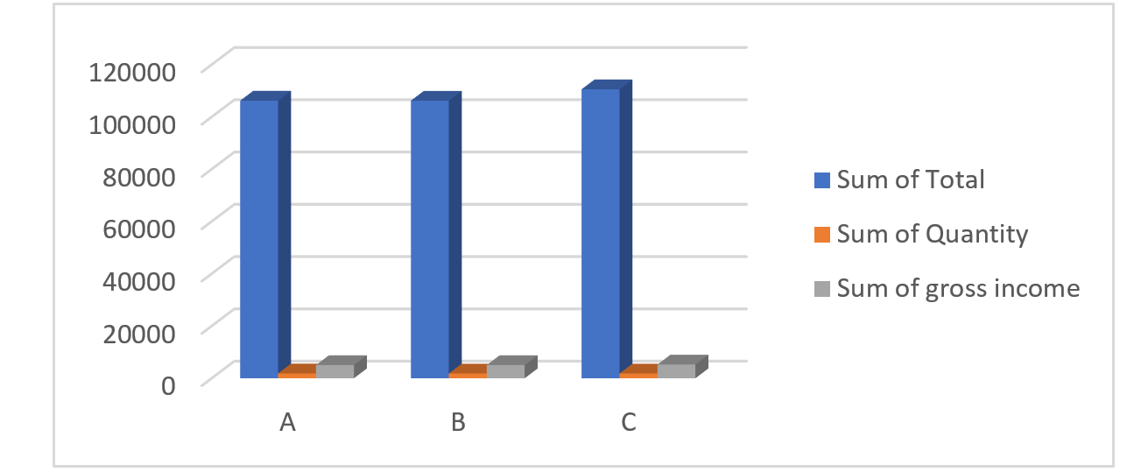

|  |  |
| --- | --- |
| **Row Labels** | **Average of Rating** |
| **A** | **7.027058824** |
| Electronic accessories | 6.911666667 |
| Fashion accessories | 6.878431373 |
| Food and beverages | 7.253448276 |
| Health and beauty | 6.9 |
| Home and lifestyle | 6.930769231 |
| Sports and travel | 7.257627119 |
| **B** | **6.818072289** |
| Electronic accessories | 7.116363636 |
| Fashion accessories | 6.722580645 |
| Food and beverages | 6.994 |
| Health and beauty | 7.1 |
| Home and lifestyle | 6.516 |
| Sports and travel | 6.509677419 |
| **C** | **7.072865854** |
| Electronic accessories | 6.747272727 |
| Fashion accessories | 7.44 |
| Food and beverages | 7.08030303 |
| Health and beauty | 6.998076923 |
| Home and lifestyle | 7.06 |
| Sports and travel | 7.028888889 |
| **Grand Total** | **6.9727** |

|  |  |
| --- | --- |
| **Row Labels** | **Average of Tax 5%** |
| A | 14.87400147 |
| B | 15.2320241 |
| C | 16.05236738 |
| **Grand Total** | **15.379369** |

* **Descriptive Statistics:**
* Summary statistics (e.g., mean, median, mode, and standard deviation) were calculated for key variables to understand general trends.
* **Visualization:**
* Charts (e.g., bar charts, pie charts, and scatter plots) and graphs were used to identify patterns and trends across branches, product lines, and customer segments.

|  |  |  |  |
| --- | --- | --- | --- |
| **Row Labels** | **Sum of Total** | **Sum of Quantity** | **Sum of gross income** |
| **A** | **106200.3705** | **1859** | **5057.1605** |
| **B** | **106197.672** | **1820** | **5057.032** |
| **C** | **110568.7065** | **1831** | **5265.1765** |